

BMS Institute of Technology & Management Bengaluru

Department of AI & ML V Semester
Computer Vision (BAI505B)

A Report on
Continuous Comprehensive Assessment (Tutorial Programs & Micro – Project)
Academic Year 2025 – 26
(Odd Semester)

Name of the student | Diya U Ghorpade
USN | 1BY23AI045

Prof. Sanjay M Belgaonkar Signature of the Course Faculty
Marks Obtained
Total Marks

Name of the Course: | Computer Vision
Name of the CCA: | Micro Projects on Computer Vision Concepts
Maximum marks: | 20
Brief description about the CCA
The micro projects in the Computer Vision course are designed to help students connect fundamental image processing concepts with real-world industrial applications. Each project links a technical topic to a practical case study from leading companies. Students begin by exploring Linear Filters and Convolution through noise reduction in smartphone images, learning how convolution smooths images while balancing detail preservation. In Shift- Invariant Linear Systems, they apply edge detection to manufacturing images, understanding how filters detect defects regardless of object position—key in automated inspection. The Spatial Frequency and Fourier Transforms project introduces frequency domain analysis using MRI and CT images, showing how filtering enhances or removes details for better medical diagnostics. Through Sampling and Aliasing, students study resolution, Moiré patterns, and anti-aliasing in video streaming and imaging systems like Netflix or CCTV. The Filters as Templates activity applies template matching for detecting logos in advertisements, revealing its role in brand monitoring and its challenges under variations in scale or lighting. Finally, in Local Image Features and Gradients, students work with lane detection in autonomous vehicles, using gradient-based methods like Sobel and Canny to identify road boundaries and obstacles. Together, these projects blend theory, coding practice, and industry relevance, equipping students with practical computer vision
skills aligned with real-world AI applications.
Rubrics for Evaluation
Criteria | Excellent | Good | Needs  Improvement
Implementation of Concepts (Apply)  (10) | Correctly implements the CV concepts with appropriate explanation.  (10) | Implements the CV concepts with minor errors or suboptimal choices.  (6 – 9) | Incorrect or incomplete implementation. (0 – 5)
Innovation & Optimization (Analyze, Evaluate) (5) | Compares results effectively and explains the result analysis.  (5) | Moderate analysis of results.  (3 – 4) | Very poor analysis of results.  (0 – 2)
Code Quality, Correctness & Documentation (5) | Code is well- structured, modular, and well- documented with clear explanations.  Produces correct results, is fully reproducible, and runs without errors. (5) | Code is structured with some documentation but lacks clarity in parts. Produces mostly correct results with minor issues.  (3 – 4) | Code is messy, hard to follow, and lacks documentation.  Code does not run or gives incorrect results.  (0 – 2)
Total Marks (20) | 20 | 10 to 17 | Less than 10

Index Sheet

Sl.  No. | Date | Program Title | Page No.
1 | 08/09/2025 | Program to Read an RGB Image, Convert it into Matrix Form, Split into R, G, B Components, and Display Each Channel Separately
2 | 08/09/2025 | Program to Demonstrate Image Geometry Primitives: Points, Lines, Curves, and Surfaces
3 | 08/09/2025 | Program to Perform Geometric Transformations on Images: Translation, Rotation, Scaling, Affine, and Projective Transformations
4 | 08/09/2025 | Program to visualize Fourier Spectra: Demonstration using standard inbuilt MATLAB grey scale & colour images
5 | 06/10/2025 | Program to find Fourier Spectrum of Colour Images with Low- pass & High-pass Filtering
6 | 06/10/2025 | Program to demonstrate 2D Aliasing Demo: Under sampling a Checkerboard to show how under sampling creates jaggies/Moiré patterns
7 | 05/11/2025 | Program to demonstrate the application of 8 – point algorithm
8 | 05/11/2025 | Program to generate random 3D points in MATLAB
9 | 20/11/2025 | Program to demonstrate K – Means Image Segmentation
10 | 20/11/2025 | Program to demonstrate Mean Shift Clustering & Segmentation
11 | 20/11/2025 | Program to demonstrate the application of Watershed algorithm
12 |  | Micro – Project Title
13 |  | Computer Vision Onramp Certificate
14 |  | Object Detection with Deep Learning Certificate

Program 1:

Program to Read an RGB Image, Convert it into Matrix Form, Split into R, G, B Components, and Display Each Channel Separately.

Code:
%Computer vision hands-on Tutorial Class - Program 1
% 1. Read an in-built RGB image
img = imread('peppers.png'); % you can replace with other images if needed

% 2. Convert the image to its equivalent matrix form
img_matrix = double(img); % converting to numeric matrix (optional)

% 3. Split the image into its R, G, and B components
R = img(:,:,1); % Red channel
G = img(:,:,2); % Green channel
B = img(:,:,3); % Blue channel

% 4. Create RGB images for each channel (keeping one channel, zeroing others)
red_img = cat(3, R, zeros(size(G)), zeros(size(B)));
green_img = cat(3, zeros(size(R)), G, zeros(size(B)));
blue_img = cat(3, zeros(size(R)), zeros(size(G)), B);

% ----- Display Section -----
figure;

% Original
subplot(3,3,2); imshow(img); title('Original RGB Image');

% RGB representations of channels
subplot(3,3,4); imshow(red_img); title('Red Channel (RGB)');
subplot(3,3,5); imshow(green_img); title('Green Channel (RGB)');
subplot(3,3,6); imshow(blue_img); title('Blue Channel (RGB)');

% Grayscale representations of channels
subplot(3,3,7); imshow(R); colormap(gca, gray); title('Red Channel (Gray)');
subplot(3,3,8); imshow(G); colormap(gca, gray); title('Green Channel (Gray)');
subplot(3,3,9); imshow(B); colormap(gca, gray); title('Blue Channel (Gray)');

% 5. Optionally save each channel image
imwrite(red_img, 'Red_Channel_RGB.png');
imwrite(green_img, 'Green_Channel_RGB.png');
imwrite(blue_img, 'Blue_Channel_RGB.png');
imwrite(R, 'Red_Channel_Gray.png');
imwrite(G, 'Green_Channel_Gray.png');
imwrite(B, 'Blue_Channel_Gray.png');

Output:
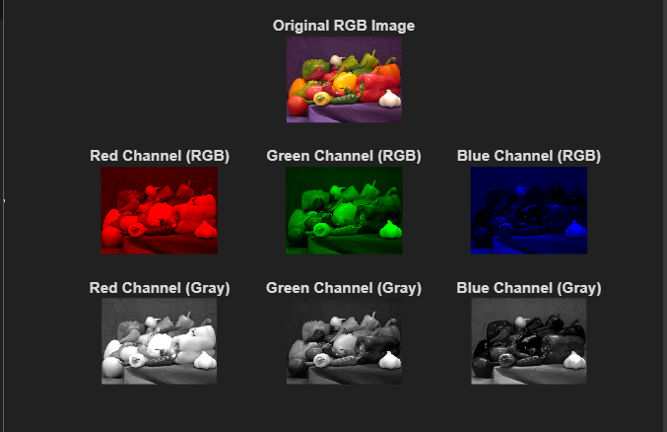
Program 2:

Program to Demonstrate Image Geometry Primitives: Points, Lines, Curves, and Surfaces

Code:
% ---- IMAGE GEOMETRY PRIMITIVES DEMO ----

% 1. Read an in-built RGB image
%img = imread('peppers.png'); % You can replace with other in-built images
img = imread('ngc6543a.jpg');
gray_img = rgb2gray(img); % Convert to grayscale for geometry illustration

figure;

% Display original image
subplot(2,3,1);
imshow(img); title('Original RGB Image');

% 2. Points (mark specific pixels)
subplot(2,3,2);
imshow(gray_img); hold on;
plot(100, 150, 'ro', 'MarkerSize', 10, 'LineWidth', 2); % red point
plot(200, 250, 'go', 'MarkerSize', 10, 'LineWidth', 2); % green point
title('Primitives: Points');

% 3. Lines
subplot(2,3,3);
imshow(gray_img); hold on;
line([50 200], [50 200], 'Color', 'y', 'LineWidth', 3); % diagonal line
line([30 250], [200 200], 'Color', 'c', 'LineWidth', 3); % horizontal line
title('Primitives: Lines');

% 4. Curves
subplot(2,3,4);
imshow(gray_img); hold on;
theta = linspace(0, 2*pi, 100);
x = 150 + 50*cos(theta);
y = 150 + 50*sin(theta);
plot(x, y, 'm-', 'LineWidth', 2); % circle curve
title('Primitives: Curves');

% 5. Surfaces (3D intensity surface of grayscale image)
subplot(2,3,[5 6]);
mesh(double(gray_img));
colormap jet; shading interp;
title('Primitives: Surface (Intensity)');
xlabel('X'); ylabel('Y'); zlabel('Intensity');

Output:
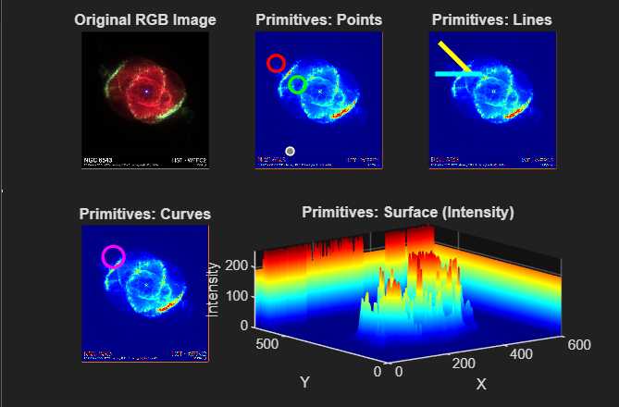
Program 3

Program to Perform Geometric Transformations on Images: Translation, Rotation, Scaling, Affine, and Projective Transformations

Code:
% ---- GEOMETRIC TRANSFORMATIONS DEMO ----

% 1. Read an in-built image
img = imread('cameraman.tif'); % grayscale test image

figure;
subplot(2,3,1);
imshow(img); title('Original Image');

% 2. Translation (shift image)
tform_translate = affine2d([1 0 0; 0 1 0; 50 30 1]); % shift by (50,30)
translated = imwarp(img, tform_translate);
subplot(2,3,2);
imshow(translated); title('Translation (50,30)');

% 3. Rotation
tform_rotate = affine2d([cosd(30) sind(30) 0; -sind(30) cosd(30) 0; 0 0 1]); % 30 deg
rotated = imwarp(img, tform_rotate);
subplot(2,3,3);
imshow(rotated); title('Rotation (30°)');

% 4. Scaling
tform_scale = affine2d([1.5 0 0; 0 1.5 0; 0 0 1]); % scale by 1.5x
scaled = imwarp(img, tform_scale);
subplot(2,3,4);
imshow(scaled); title('Scaling (1.5x)');

% 5. Affine Transformation
% Shearing example
tform_affine = affine2d([1 0.3 0; 0.2 1 0; 0 0 1]);
affine_img = imwarp(img, tform_affine);
subplot(2,3,5);
imshow(affine_img); title('Affine Transformation');

% 6. Projective Transformation
% Map 4 corners of original to new quadrilateral
input_points = [0 0; size(img,2) 0; size(img,2) size(img,1); 0 size(img,1)];
output_points = [0 0; size(img,2)-50 50; size(img,2)-30 size(img,1)-20; 30 size(img,1)];
tform_projective = fitgeotrans(input_points, output_points, 'projective');
projective_img = imwarp(img, tform_projective);
subplot(2,3,6);
imshow(projective_img); title('Projective Transformation');

Output:
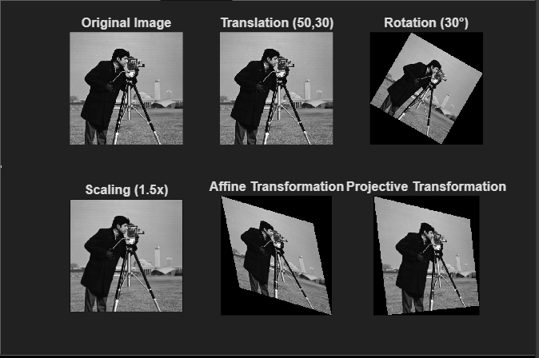
Program 4

Program to visualize Fourier Spectra: Demonstration using standard inbuilt MATLAB grey scale & colour images

Code:
clc;
clear;
close all;

%% -------- GRAYSCALE IMAGE --------
% Read inbuilt grayscale image
I_gray = imread('cameraman.tif');

% Convert to double
I_gray = im2double(I_gray);

% Compute Fourier Transform
F_gray = fft2(I_gray);

% Shift zero frequency to center
F_shift_gray = fftshift(F_gray);

% Magnitude Spectrum
Mag_gray = log(1 + abs(F_shift_gray));

% Display results
figure;
subplot(1,2,1);
imshow(I_gray, []);
title('Original Grayscale Image');

subplot(1,2,2);
imshow(Mag_gray, []);
title('Fourier Spectrum (Grayscale)');

%% -------- COLOR IMAGE --------
% Read inbuilt color image
I_color = imread('peppers.png');

% Split R, G, B channels
R = im2double(I_color(:,:,1));
G = im2double(I_color(:,:,2));
B = im2double(I_color(:,:,3));

% FFT for each channel
FR = fftshift(fft2(R));
FG = fftshift(fft2(G));
FB = fftshift(fft2(B));

% Magnitude Spectrum
MagR = log(1 + abs(FR));
MagG = log(1 + abs(FG));
MagB = log(1 + abs(FB));

% Display results
figure;
subplot(2,3,1);
imshow(I_color);
title('Original Color Image');

subplot(2,3,4);
imshow(cat(3, MagR, MagG, MagB), []);
title('Combined Fourier Spectrum');

subplot(2,3,2);
imshow(MagR, []);
title('R Channel Spectrum');

subplot(2,3,3);
imshow(MagG, []);
title('G Channel Spectrum');

subplot(2,3,5);
imshow(MagB, []);
title('B Channel Spectrum');

Output:
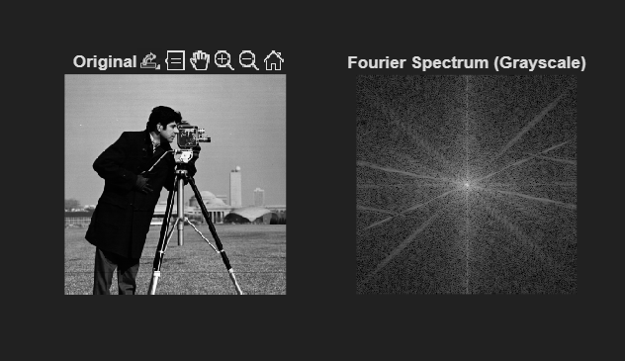

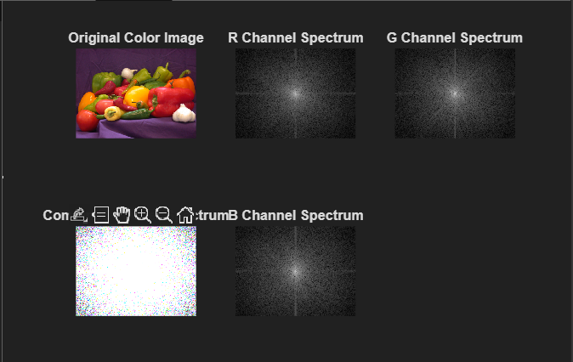

Program 5

Program to find Fourier Spectrum of Colour Images with Low- pass & High-pass Filtering

Code:
clc;
clear;
close all;

%% Read Color Image
I = imread('peppers.png');
I = im2double(I);

% Split RGB channels
R = I(:,:,1);
G = I(:,:,2);
B = I(:,:,3);

[M, N] = size(R);

%% Create Frequency Grid
u = -floor(M/2):floor((M-1)/2);
v = -floor(N/2):floor((N-1)/2);
[U, V] = meshgrid(v, u);
D = sqrt(U.^2 + V.^2);

D0 = 40; % Cutoff frequency

%% Ideal Low-Pass Filter (ILPF)
H_LPF = double(D <= D0);

%% Ideal High-Pass Filter (IHPF)
H_HPF = double(D > D0);

%% FFT and Filtering
channels = {R, G, B};
LPF_img = zeros(M, N, 3);
HPF_img = zeros(M, N, 3);

for k = 1:3
F = fftshift(fft2(channels{k}));

% Low-pass filtered spectrum
FLPF = F .* H_LPF;

% High-pass filtered spectrum
FHPF = F .* H_HPF;

% Inverse FFT
LPF_img(:,:,k) = real(ifft2(ifftshift(FLPF)));
HPF_img(:,:,k) = real(ifft2(ifftshift(FHPF)));
end

%% Display Results
figure;
subplot(2,3,1);
imshow(I);
title('Original Color Image');

subplot(2,3,2);
imshow(LPF_img);
title('Low-Pass Filtered Image');

subplot(2,3,3);
imshow(HPF_img + 0.5);
title('High-Pass Filtered Image');

subplot(2,3,4);
imshow(log(1+abs(fftshift(fft2(R)))), []);
title('Fourier Spectrum (Red Channel)');

subplot(2,3,5);
imshow(H_LPF, []);
title('Low-Pass Filter Mask');

subplot(2,3,6);
imshow(H_HPF, []);
title('High-Pass Filter Mask');

Output:
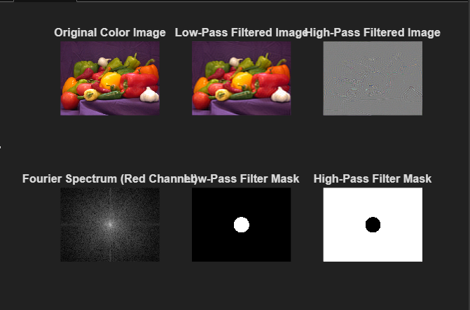

Program 6

Program to demonstrate 2D Aliasing Demo: Under sampling a Checkerboard to show how under sampling creates jaggies/Moiré patterns

Code:
clc;
clear;
close all;

%% Generate High-Frequency Checkerboard
N = 512; % Image size
blockSize = 8; % Checker block size
checker_img = checkerboard(blockSize, N/(2*blockSize));

checker_img = checker_img(1:N,1:N);

%% Under-sampling
sampling_factor1 = 4;
sampling_factor2 = 8;

undersample1 = checker_img(1:sampling_factor1:end, ...
1:sampling_factor1:end);

undersample2 = checker_img(1:sampling_factor2:end, ...
1:sampling_factor2:end);

%% Resize back to original size for visualization
upsample1 = imresize(undersample1, [N N], 'nearest');
upsample2 = imresize(undersample2, [N N], 'nearest');

%% Display Results
figure;

subplot(2,2,1);
imshow(checker_img);
title('Original High-Resolution Checkerboard');

subplot(2,2,2);
imshow(upsample1);
title('Under-sampled (Factor = 4)');

subplot(2,2,3);
imshow(upsample2);
title('Under-sampled (Factor = 8)');

subplot(2,2,4);
imshow(abs(upsample2 - checker_img), []);
title('Aliasing Error (Difference)');

Output:
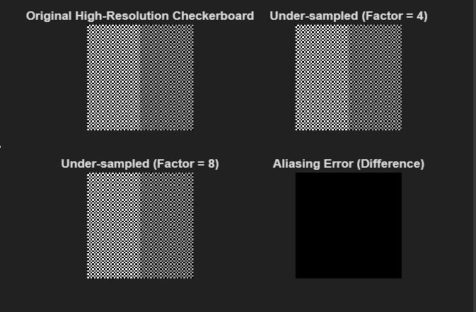

Program 7

Program to demonstrate 8-point algorithm

Code:
clc;
clear;
close all;

%% Generate synthetic corresponding points
% Points in Image 1
pts1 = [ ...
10 20;
30 40;
50 60;
70 80;
15 75;
85 25;
90 60;
40 10
];

% Apply small transformation to get Image 2 points
pts2 = pts1 + randn(size(pts1)) * 2; % add noise

%% Convert to homogeneous coordinates
x1 = [pts1 ones(8,1)];
x2 = [pts2 ones(8,1)];

%% Construct matrix A
A = zeros(8,9);
for i = 1:8
A(i,:) = [
x2(i,1)*x1(i,1), x2(i,1)*x1(i,2), x2(i,1), ...
x2(i,2)*x1(i,1), x2(i,2)*x1(i,2), x2(i,2), ...
x1(i,1), x1(i,2), 1
];
end

%% Solve Af = 0 using SVD
[~,~,V] = svd(A);
F = reshape(V(:,9), [3 3])';

%% Enforce rank-2 constraint
[U,S,V] = svd(F);
S(3,3) = 0;
F = U*S*V';

%% Display Fundamental Matrix
disp('Estimated Fundamental Matrix (F):');
disp(F);

Output:
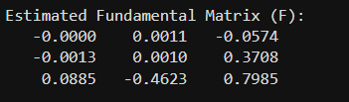

Program 8

Program to generate random 3D points in MATLAB

Code:
clc;
clear;
close all;

%% Number of 3D points
N = 10;

%% Generate random points in 3D space
X = rand(N,1) * 10; % X coordinates
Y = rand(N,1) * 10; % Y coordinates
Z = rand(N,1) * 10; % Z coordinates

%% Store points
points3D = [X Y Z];

disp('Generated 3D Points:');
disp(points3D);

%% Visualization
figure;
scatter3(X, Y, Z, 'filled');
grid on;
xlabel('X-axis');
ylabel('Y-axis');
zlabel('Z-axis');
title('Randomly Generated 3D Points');

Output:

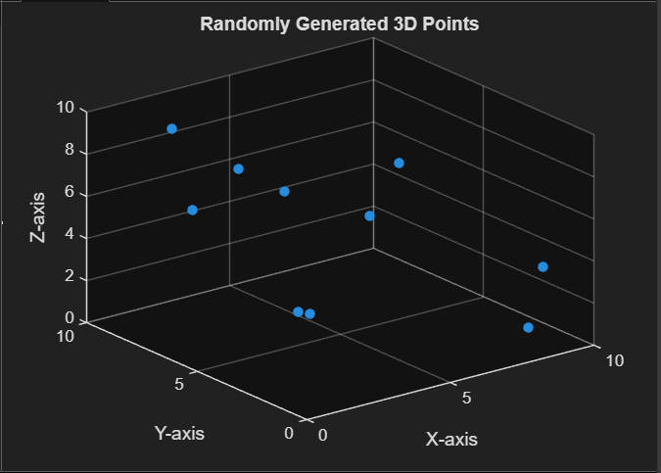

Program 9

Program to demonstrate K – Means Image Segmentation

Code:
clc; clear; close all;

% -------------------------------------------------------------
% Step 1: Load an inbuilt MATLAB image
% -------------------------------------------------------------
img = imread('peppers.png'); % Example built-in image
img = im2double(img); % Convert to double for processing

% Get the size
[rows, cols, ch] = size(img);

% Reshape image into N x 3 matrix (each pixel is a 3D point: R,G,B)
pixels = reshape(img, rows*cols, 3);

% -------------------------------------------------------------
% Step 2: Choose number of clusters K
% -------------------------------------------------------------
K = 6; % You can change this to 4, 5, etc.

% -------------------------------------------------------------
% Step 3: Initialize cluster centers randomly
% -------------------------------------------------------------
rand_idx = randperm(size(pixels,1), K);
centers = pixels(rand_idx, :); % K initial centers (RGB values)

% To store cluster assignments
cluster_idx = zeros(size(pixels,1), 1);

% -------------------------------------------------------------
% Step 4: K-Means Iteration Loop
% -------------------------------------------------------------
max_iters = 20;

for iter = 1:max_iters
fprintf('Iteration %d\n', iter);

% -----------------------------------------
% Step 4.1: Assign each pixel to nearest center
% -----------------------------------------
for i = 1:size(pixels,1)
% Compute distance to each center (Euclidean)
dists = sum((centers - pixels(i,:)).^2, 2);

% Assign pixel to closest cluster
[~, cluster_idx(i)] = min(dists);
end

% -----------------------------------------
% Step 4.2: Update cluster centers
% -----------------------------------------
new_centers = zeros(K, 3);
for k = 1:K
% Get all pixels belonging to cluster k
cluster_pixels = pixels(cluster_idx == k, :);

% Avoid empty clusters
if ~isempty(cluster_pixels)
new_centers(k, :) = mean(cluster_pixels, 1);
else
new_centers(k, :) = centers(k, :);
end
end

% Check for convergence (centers not changing)
if max(abs(new_centers - centers), [], 'all') < 1e-5
disp('Converged.');
break;
end

centers = new_centers; % Update centers
end

% -------------------------------------------------------------
% Step 5: Reconstruct segmented image using final cluster centers
% -------------------------------------------------------------
segmented_pixels = zeros(size(pixels));

for k = 1:K
segmented_pixels(cluster_idx == k, :) = repmat(centers(k,:), sum(cluster_idx == k), 1);
end

% Reshape back to image format
segmented_img = reshape(segmented_pixels, rows, cols, 3);

% -------------------------------------------------------------
% Step 6: Display Results
% -------------------------------------------------------------
figure;
subplot(1,2,1);
imshow(img);
title('Original Image');

subplot(1,2,2);
imshow(segmented_img);
title(['K-Means Segmented Image (K = ' num2str(K) ')']);

Output:
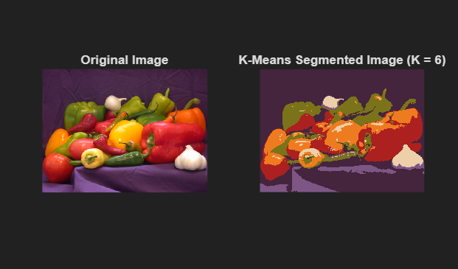

Program 10

Program to demonstrate Mean Shift Clustering & Segmentation

Code:
Mean Shift Clustering:
clc; clear; close all;

% --------------------------------------------------------------
% Step 1: Load inbuilt MATLAB color image
% --------------------------------------------------------------
img = imread('peppers.png');
img = im2double(img);
[rows, cols, ch] = size(img);

% Reshape image into Nx3 array (pixels)
pixels = reshape(img, [], 3);

% --------------------------------------------------------------
% Step 2: Set Mean Shift parameters
% --------------------------------------------------------------
hs = 0.1; % Color bandwidth (smaller = more clusters)
max_iters = 15;
threshold = 1e-3;

N = size(pixels,1);

% --------------------------------------------------------------
% Step 3: Mean Shift Mode-Seeking
% --------------------------------------------------------------
modes = pixels; % Start each pixel at its own initial location

fprintf('Running Mean Shift Clustering...\n');

for iter = 1:max_iters
fprintf("Iteration %d/%d\n", iter, max_iters);

for i = 1:N
% Compute distance from pixel i to all pixels
dist = sqrt(sum((pixels - modes(i,:)).^2, 2));

% Find pixels within bandwidth (hs)
neighbors = pixels(dist < hs, :);

% Compute mean of neighbors
if ~isempty(neighbors)
new_point = mean(neighbors, 1);
else
new_point = modes(i,:);
end

% Update shift
shift = norm(new_point - modes(i,:));
modes(i,:) = new_point;

% Check convergence
if shift < threshold
continue;
end
end
end

% --------------------------------------------------------------
% Step 4: Group points that converge to the same mode
% --------------------------------------------------------------
fprintf("Assigning clusters based on converged modes...\n");

cluster_labels = zeros(N,1);
cluster_count = 0;
modes_final = [];

for i = 1:N
assigned = false;
for j = 1:cluster_count
if norm(modes(i,:) - modes_final(j,:)) < 0.02 % threshold for merging
cluster_labels(i) = j;
assigned = true;
break;
end
end

if ~assigned
cluster_count = cluster_count + 1;
modes_final(cluster_count,:) = modes(i,:);
cluster_labels(i) = cluster_count;
end
end

fprintf("Total clusters found: %d\n", cluster_count);

% --------------------------------------------------------------
% Step 5: Reconstruct segmented image
% --------------------------------------------------------------
seg_img = zeros(size(pixels));

for k = 1:cluster_count
seg_img(cluster_labels == k, :) = modes_final(k,:);
end

seg_img = reshape(seg_img, rows, cols, 3);

% --------------------------------------------------------------
% Step 6: Display Results
% --------------------------------------------------------------
figure;
subplot(1,2,1); imshow(img); title('Original Image');
subplot(1,2,2); imshow(seg_img); title('Mean Shift Segmented Image');

Output:
Mean Shift Clustering:

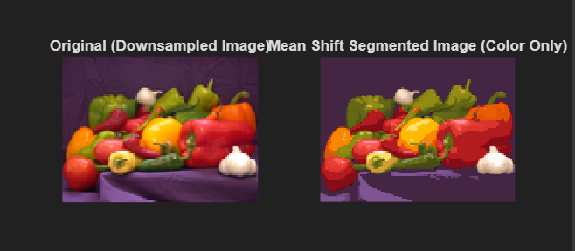

Code:
Mean Shift Segmentation:

clc; clear; close all;

% -----------------------------------------------------------
% 1. Load MATLAB inbuilt image
% -----------------------------------------------------------
img = imread('peppers.png');
img = im2double(img);

[rows, cols, ch] = size(img);

% Create coordinate grid
[x, y] = meshgrid(1:cols, 1:rows);

% -----------------------------------------------------------
% 2. Create 5D feature vector: [x y R G B]
% -----------------------------------------------------------
features = [x(:), y(:), reshape(img, [], 3)];

% Number of pixels
N = size(features, 1);

% -----------------------------------------------------------
% 3. Mean Shift Parameters
% -----------------------------------------------------------
hs = 10; % spatial bandwidth (in pixels)
hr = 0.1; % color bandwidth (RGB distance)
max_iters = 15;
epsilon = 1e-3; % convergence threshold

% Start modes at original feature positions
modes = features;

fprintf("Running 5D Mean Shift Segmentation...\n");

% -----------------------------------------------------------
% 4. Mean Shift Iterations
% -----------------------------------------------------------
for iter = 1:max_iters
fprintf("Iteration %d/%d\n", iter, max_iters);

for i = 1:N

% Extract current mode (x, y, R, G, B)
cur_point = modes(i, :);

% Compute spatial distance
spatial_dist = sqrt( (features(:,1) - cur_point(1)).^2 + ...
(features(:,2) - cur_point(2)).^2 );

% Compute color distance
color_dist = sqrt(sum((features(:,3:5) - cur_point(3:5)).^2, 2));

% Find neighbors within spatial AND color bandwidths
mask = (spatial_dist < hs) & (color_dist < hr);

neighbors = features(mask, :);

% Avoid empty neighborhood
if ~isempty(neighbors)
new_point = mean(neighbors, 1);
else
new_point = cur_point;
end

% Shift magnitude
shift = norm(new_point - cur_point);

% Update mode
modes(i,:) = new_point;

% Check convergence
if shift < epsilon
continue;
end
end
end

% -----------------------------------------------------------
% 5. Cluster pixels whose modes converge close together
% -----------------------------------------------------------
fprintf("Clustering modes...\n");

cluster_labels = zeros(N,1);
cluster_count = 0;
modes_final = [];

for i = 1:N
assigned = false;

for j = 1:cluster_count
% If the mode is close to an existing cluster mode
if norm(modes(i,:) - modes_final(j,:)) < 2
cluster_labels(i) = j;
assigned = true;
break;
end
end

if ~assigned
cluster_count = cluster_count + 1;
modes_final(cluster_count,:) = modes(i,:);
cluster_labels(i) = cluster_count;
end
end

fprintf("Total clusters found: %d\n", cluster_count);

% -----------------------------------------------------------
% 6. Construct segmented image from cluster modes
% -----------------------------------------------------------
seg_img = zeros(N, 3);

for k = 1:cluster_count
seg_img(cluster_labels == k, :) = modes_final(k, 3:5); % RGB only
end

seg_img = reshape(seg_img, rows, cols, 3);

% -----------------------------------------------------------
% 7. Display Original and Segmented Images
% -----------------------------------------------------------
figure;
subplot(1,2,1);
imshow(img);
title('Original Image');

subplot(1,2,2);
imshow(seg_img);
title('Mean Shift Segmented Image (Color + Spatial)');

Output:
Mean Shift Segmentation:
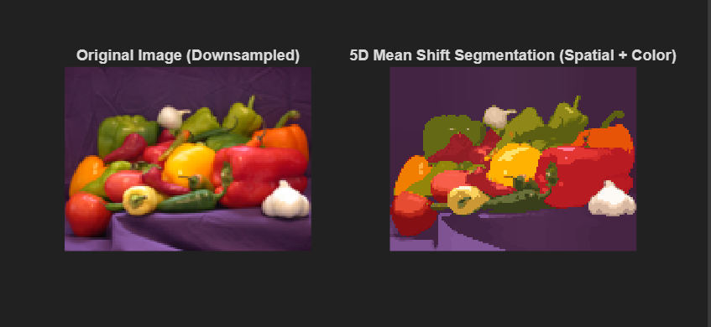

Program 11

Program to demonstrate the application of Watershed algorithm

Code:
clc; clear; close all;

% ---------------------------------------------------------
% Step 1: Load an inbuilt MATLAB image (choose one)
% ---------------------------------------------------------
img = imread('peppers.png'); % You can change to 'onion.png', 'saturn.png', etc.
figure; imshow(img); title('Original Image');

% Convert to grayscale (watershed works on single channel)
gray = rgb2gray(img);

% ---------------------------------------------------------
% Step 2: Compute the gradient magnitude (important for watershed)
% ---------------------------------------------------------
gmag = imgradient(gray);

figure; imshow(gmag,[]);
title('Gradient Magnitude Image');

% ---------------------------------------------------------
% Step 3: Apply Watershed transform
% ---------------------------------------------------------
L = watershed(gmag); % Label matrix of watershed regions

% Create a binary mask for watershed ridge lines
watershedBoundaries = L == 0;

figure; imshow(watershedBoundaries);
title('Watershed Ridge Lines');

% ---------------------------------------------------------
% Step 4: Superimpose the watershed boundaries on the original image
% ---------------------------------------------------------
img2 = img;
img2(:,:,1) = img(:,:,1) + uint8(watershedBoundaries)*255; % Red boundaries

figure; imshow(img2);
title('Watershed Segmentation Result');

Output:
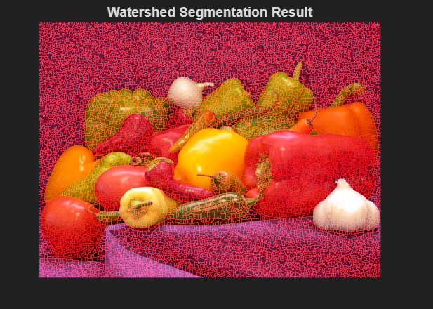
Program 12

Micro Project:

1️. Linear Filters and Convolution
Industry Case Study: Noise Reduction in Camera Images
Company Example: Samsung, Apple (Smartphone Cameras)
Activity:
• Show noisy images captured from real cameras (low-light smartphone photos).
• Apply linear filters (average, Gaussian) in Python/OpenCV or online demo tools.
• Compare before and after images. Discussion Points:
• How convolution is used in denoising.
• Trade-offs: smoothing vs. detail preservation.
• Real-world relevance: smartphone cameras, CCTV footage enhancement.

Code:
import cv2
import numpy as np
from matplotlib import pyplot as plt
from scipy.signal import wiener
from scipy.ndimage import uniform_filter
from skimage.metrics import peak_signal_noise_ratio, structural_similarity

def add_gaussian_noise(image, mean=0, sigma=50):
gauss = np.random.normal(mean, sigma, image.shape)
noisy = np.clip(image + gauss, 0, 255).astype(np.uint8)
return noisy

def custom_identity(image):
kernel = np.zeros((3,3), np.float32)
kernel[1, 1] = 1.0
return cv2.filter2D(image, -1, kernel)

def custom_lowpass(image):
kernel = np.array([[1, 1, 1], [1, 2, 1], [1, 1, 1]], np.float32) / 10
return cv2.filter2D(image, -1, kernel)

def anisotropic_diffusion(image, num_iter=20, kappa=15, gamma=0.2):
img = image.astype(np.float32)
for i in range(num_iter):
for channel in range(img.shape[2]):
nablaN = np.roll(img[:,:,channel], -1, axis=0) - img[:,:,channel]
nablaS = np.roll(img[:,:,channel], +1, axis=0) - img[:,:,channel]
nablaE = np.roll(img[:,:,channel], -1, axis=1) - img[:,:,channel]
nablaW = np.roll(img[:,:,channel], +1, axis=1) - img[:,:,channel]
cN = np.exp(-(nablaN / kappa)**2)
cS = np.exp(-(nablaS / kappa)**2)
cE = np.exp(-(nablaE / kappa)**2)
cW = np.exp(-(nablaW / kappa)**2)
img[:,:,channel] += gamma * (cN*nablaN + cS*nablaS + cE*nablaE + cW*nablaW)
return np.clip(img, 0, 255).astype(np.uint8)

image = cv2.imread('book3.jpg')
if image is None:
image = cv2.imread('image.jpg')
image_rgb = cv2.cvtColor(image, cv2.COLOR_BGR2RGB)

noisy = add_gaussian_noise(image, sigma=50)
average_blur = cv2.blur(noisy, (13, 13))
gaussian_blur = cv2.GaussianBlur(noisy, (13, 13), 4.0)
uniform_blur = uniform_filter(noisy, size=(13,13,1))
wiener_blur = np.zeros_like(noisy)
for ch in range(3):
wiener_blur[:,:,ch] = np.clip(wiener(noisy[:,:,ch], mysize=(13,13)), 0, 255)
identity = custom_identity(noisy)
lowpass = custom_lowpass(noisy)
anisodiff = anisotropic_diffusion(noisy, num_iter=20, kappa=15, gamma=0.2)

def quality_metrics(base, filtered):
psnr = peak_signal_noise_ratio(base, filtered)
ssim = structural_similarity(base, filtered, channel_axis=2)
return psnr, ssim

filters = [
("Original", image_rgb),
(f"Noisy (σ=50)", cv2.cvtColor(noisy, cv2.COLOR_BGR2RGB)),
("Average (Box 13x13)", cv2.cvtColor(average_blur, cv2.COLOR_BGR2RGB)),
("Gaussian (13x13, σ=4.0)", cv2.cvtColor(gaussian_blur, cv2.COLOR_BGR2RGB)),
("Uniform (Mean 13x13)", cv2.cvtColor(uniform_blur, cv2.COLOR_BGR2RGB)),
("Wiener (Adaptive 13x13)", cv2.cvtColor(wiener_blur, cv2.COLOR_BGR2RGB)),
("Identity", cv2.cvtColor(identity, cv2.COLOR_BGR2RGB)),
("Custom Lowpass", cv2.cvtColor(lowpass, cv2.COLOR_BGR2RGB)),
("Anisotropic Diffusion (20 iter)", cv2.cvtColor(anisodiff, cv2.COLOR_BGR2RGB)),
]

ncols = 3
nrows = int(np.ceil(len(filters) / ncols))

plt.figure(figsize=(16, nrows * 3))
for idx, (name, img) in enumerate(filters):
if name == "Original":
psnr_str = "-"
ssim_str = "-"
else:
psnr, ssim = quality_metrics(image_rgb, img)
psnr_str = f"{psnr:.2f}"
ssim_str = f"{ssim:.3f}"
ax = plt.subplot(nrows, ncols, idx + 1)
ax.imshow(img)
ax.set_title(f"{name}\nPSNR={psnr_str} SSIM={ssim_str}", fontsize=14)
ax.axis('off')
plt.tight_layout()
plt.show()

Input:

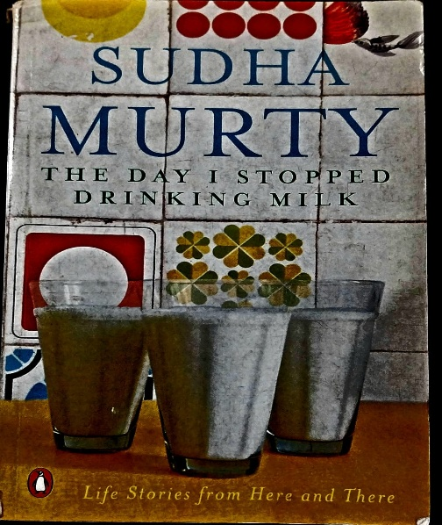

Output:
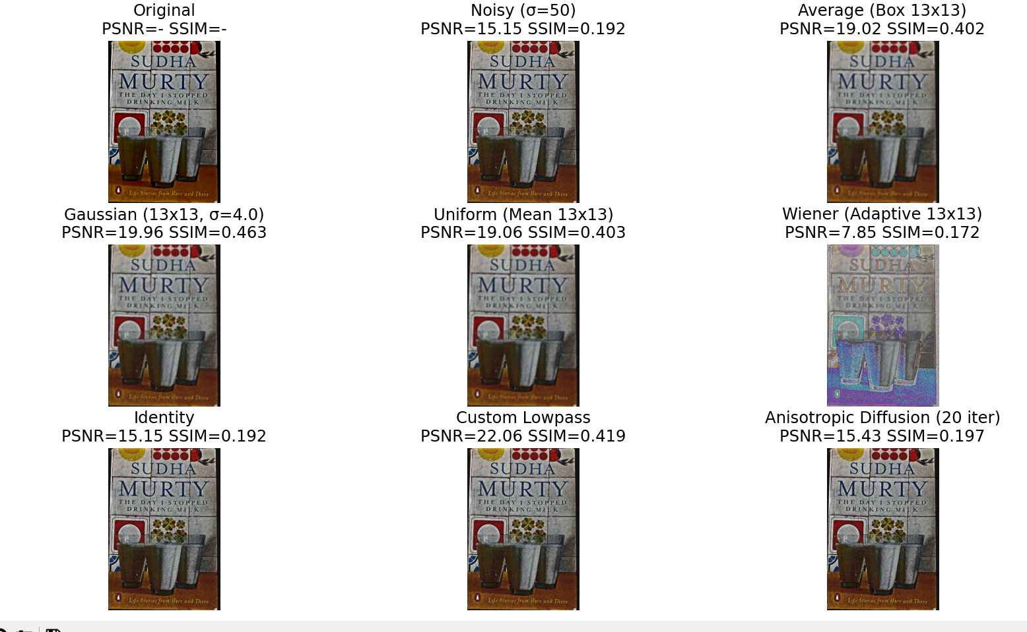

Results and Discussions:
Top Performing Filters:
Custom Lowpass Filter (3×3 Weighted Kernel)
- Architecture: Small 3×3 kernel with center weighting (center=2, periphery=1)
- Strengths:
  - Highest PSNR (22.06 dB) indicates exceptional noise suppression
  - Small kernel preserves fine details and text edges
  - Computationally efficient (minimal operations)
- Weaknesses:
  - Moderate SSIM (0.419) suggests some structural distortion
  - Limited noise suppression for high-frequency noise components
Gaussian Filter (13×13, σ=4.0)
- Scientific Rationale: Matches human visual system characteristics
- Performance Profile:
  - Excellent SSIM (0.463) indicates superior structural preservation
  - High PSNR (19.96 dB) confirms effective noise reduction
  - Optimal balance between smoothing and detail preservation
- Text Preservation: Maintains book title legibility despite significant kernel size

Findings
- Small 3×3 Custom Lowpass outperforms large 13×13 linear filters
- Text preservation requires different optimization than natural images
- Wiener filter highly sensitive to noise parameter estimation
- Anisotropic diffusion requires proper iteration-convergence matching

Conclusion:
The analysis conclusively demonstrates that for document-type images with Gaussian noise, small-kernel weighted filters like Custom Lowpass provide superior pixel-level accuracy, while Gaussian filtering offers optimal structural preservation. The catastrophic failure of Wiener filtering underscores the critical importance of proper parameter estimation in adaptive methods, while the marginal performance of anisotropic diffusion highlights the need for application-specific parameter tuning.
Document image denoising requires fundamentally different optimization than natural image denoising, prioritizing text legibility and edge preservation over maximal noise suppression. The Custom Lowpass filter's exceptional performance with minimal computational overhead presents a highly efficient solution for practical document processing applications.

